# Abstract

Keywords: beta diversity

# Introduction

Community ecologists remember that coexistence at its core depends on births, deaths and dispersal. In urban ecosystems, one can distill patch types down into two - those that have had species' birth or deaths influenced by people, or those that have not (e.g., remnant forests). People place - or eliminate - species on the landscape, facilitating patterns of coexistence, but side-step natural rates of birth and death, and patterns of dispersal. Beta diversity, or the fundamental connection between local and regional diversity, shifts with scale and also depends on births, deaths and dispersal. As such, it is predicted to change with scale in urban remnant habitats, but not in non-remnant habitats due to the ecological disconnect people impose between coexistence and demography. Nevertheless, this biodiversity exists, and is important as such assemblages confer substantial ecosystem services to dense human populations.

Urban ecosystems exhibit a highly heterogeneous mosaic of habitat patches, emphasizing the potential for strong environmental gradients to unfold. Since urban ecosystems are characterized by such extreme spatial heterogeneity, it is essential that b-diversity be quantified and understood. Indeed, it may be that a lack of understanding this dimension of biodiversity may be a source of many inconsistencies regarding the effect of drivers of changes in urban biodiversity. One key area that this may be the case is in how dispersal can drive the relationship between diversity components (a, b, g). This is, as stated above, because people are fine agents of dispersal, homogenizing species assemblages in highly human controlled patches (see below). XXX and XXX (XXX) showed that as dispersal increases, beta diversity declines, because competitive dominant species often exclude other species locally, reducing a-diversity and regional (g) diversity declines.

But why should beta diversity exhibit different patterns in urban places? One reason lies in the nature of what is the agent of dispersal and lack of the competitive dominants taking over at high dispersal. In "human-controlled" patches, high dispersal is taking place, beta diversity is low, but a and g should remain high because people relax competition. No competitive dominant is allowed to take over. However, in remnant patches with natural demography, one should observe competitive dominants emerge as dispersal is high - and this is indeed the case - reducing alpha and beta diversity. In essence, where humans side-step natural demography, especially as it relates to augmenting dispersal, and relaxing competition, beta diversity, while low, should not scale, and alpha and gamma diversity should be high.

# Methods

## Tree inventory data

We made use of a large data set created as a part of a tree inventory effort across four cities in the United States: Austin, Texas, Houston, Texas, Portland, Oregon, and San Antonio, Texas (Figure 1). Forest composition of planted and naturally recruited individuals were identified to species using plot-based random sampling (Nowak et al. 2008, http://nrs.fs.fed.us/-data/urban/; N = 209). Dates of inventories ranged from 1999 to 2009. Land-use was noted during sampling, with designations following the USDA Forest Service’s I-Tree Eco User’s Manual (v 5.0, www. itreetools.org). In addition to the counts of each species of tree, the carbon storage and biomass were calculated by XXXXXXXXX. For our analysis we compared forest land uses with all other land uses, representing XXXXX. This was done because XXXXX. Plot size was 0.04 ha, and all individuals 2.54 cm DBH or more were counted and identified. Across the four cities included in our analysis, there were a total of 181 sites in San Antonio, 165 sites in Austin, 122 sites in Houston, and 113 sites in Portland (Table 1).

## Quantifying diversity

To quantify the difference in diversity between forest and other land use categories we estimated four metrics of diversity: species richness, rarified species richness, species probability of interspecific encounter (Hurlbert 1971), and the total number of individuals, or abundance. But because the plot sizes were small, and often contained < 3 species (335/581 sites) we needed to aggregate sites into pseudo-sampling sites. To do this, we performed a resampling analysis were we treated each FIA site as an independent sampling unit and randomly drew 5 sites that were classified as forest and 5 sites that were classified as other. We then used this random sample as an aggregate to make a sampling matrix, cumulatively over the 10 total sites, stratified by landuse. We performed this resampling procedure 1,000 times for each treatment in each city to ensure we encompassed the variability across the different sites. To ensure the number of sites sampled did not influence our results, we repeated the above analysis for 10, 15, and 20 sites randomly sampled each time and found qualitatively and quantitatively similar patterns in our results.

While the above analysis was focused on tree abundance and diversity, for each randomly sampled aggregate we also calculated the cumulative biomass and carbon for each random sample to compare the differences between land uses.

## Statistical analyses

We tested for broad patterns of beta diversity between forest and other land uses, across all four cities (treated as replicated here in our analysis). Because of this, we used a mixed effects model where the response variable was the diversity variable - beta diversity of species richness, beta diversity of rarified species richness, and beta diversity of probability interspecific encounter rate - and the predictor variable was a categorical effect of ‘treatment (i.e., either forest or other landuse type), with a random effect for city to account for the inherent differences among cities. A gaussian error distribution was assumed for model fitting. Each model had a sample size of 8000 observations, 1000 per treatment X city combination (see methods above). To estimate p-values we used Satterthwaite's degrees of freedom method ([Kuznetsova et al. 2017](https://www.jstatsoft.org/article/view/v082i13)) and models were fit using the lme4 package and method implementation ([Bates et al. 2015](https://www.jstatsoft.org/article/view/v067i01)).

## Data analysis and availability

All data analysis was conducted in R version 4.1.2 (R Core Team 2022) and relied heavily on tools from the Tidyverse ([Wickham et al. 2019](https://joss.theoj.org/papers/10.21105/joss.01686)). All code (and hopefully data?) are publicly available at this GitHub repository and will be permanently archived upon acceptance of this manuscript in a Zenodo repository.

# Results

Using a total of 581 sites across the four cities, we found that there was an increased overall species richness for other landuse types compared with forest landuse types (Table 1), with XXX % species uniquely found in forest for Austin, Houston, San Antonio, and Portland respectively, and XXXX% species uniquely found in Austin, Houston, San Antonio, and Portland respectively (Figure 2).

Our resampling analysis showed that for alpha diversity, the number of individuals was consistently higher in forest land uses than others, but there was negligible difference between species richness, and when species richness was rarified, there was an increase in rarified richness in other land uses compared with forest land use (Figure 3). And lastly, we found a moderately slightly higher probability of specific encounter in other land uses than forest land uses (Figure 3).

For beta diversity we found that there was strong evidence for increased beta diversity in other land uses compared with forest land use, and the effect size was largest for beta diversity of species richness, followed by beta diversity of species interspecific encounter rate, and beta diversity of rarified richness (Figure 4; Table 2). Xxxxx.

XXXXX.

Lastly, we found that both biomass and carbon were greater in forest land uses than ‘other’ land uses (Figure 5).

# Discussion

Figures

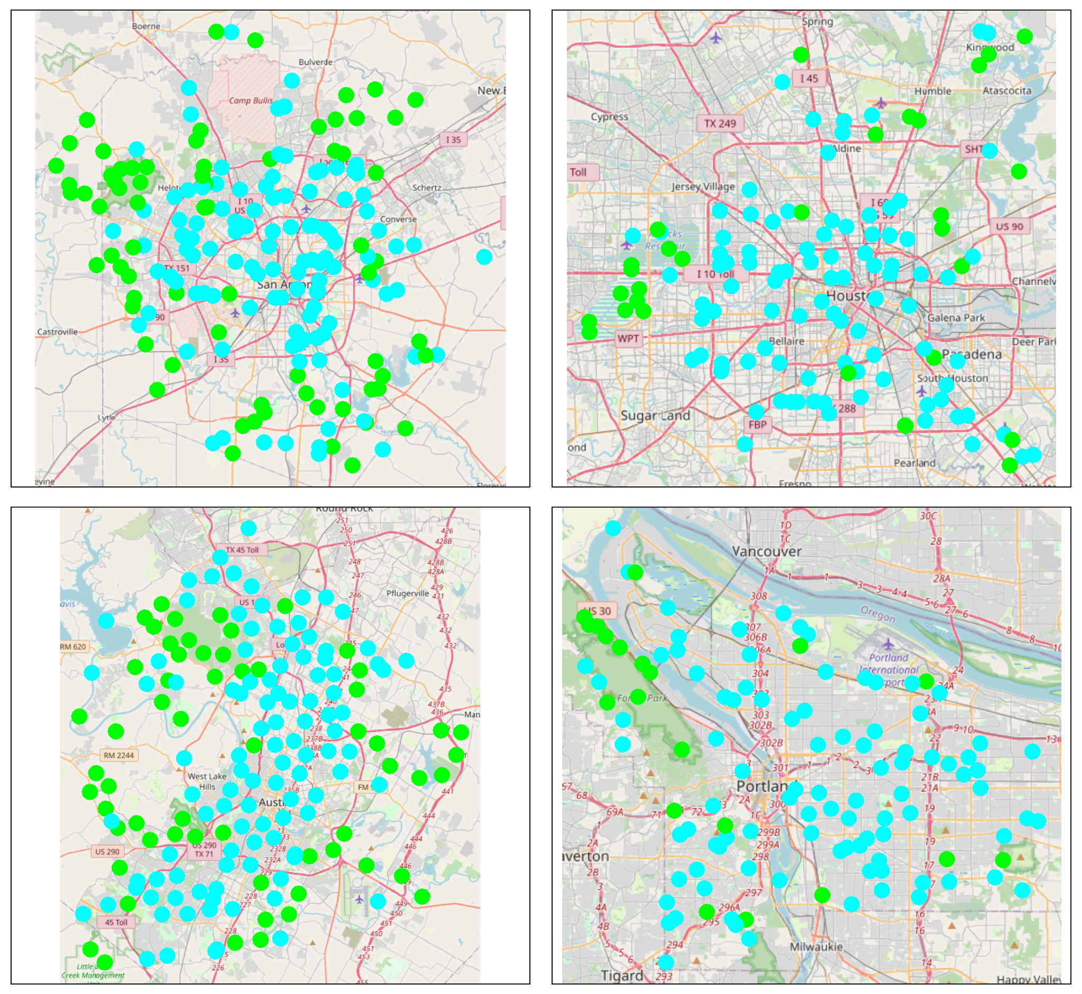

Figure 1. A map of the four cities, San Antonio, Texas (top left), Houston, Texas (top right), Austin, Texas (bottom left), and Portland, Oregon (bottom right). The blue points represent FIA sites we classified as ‘other’ and the green points represent FIA sites classified as forest.

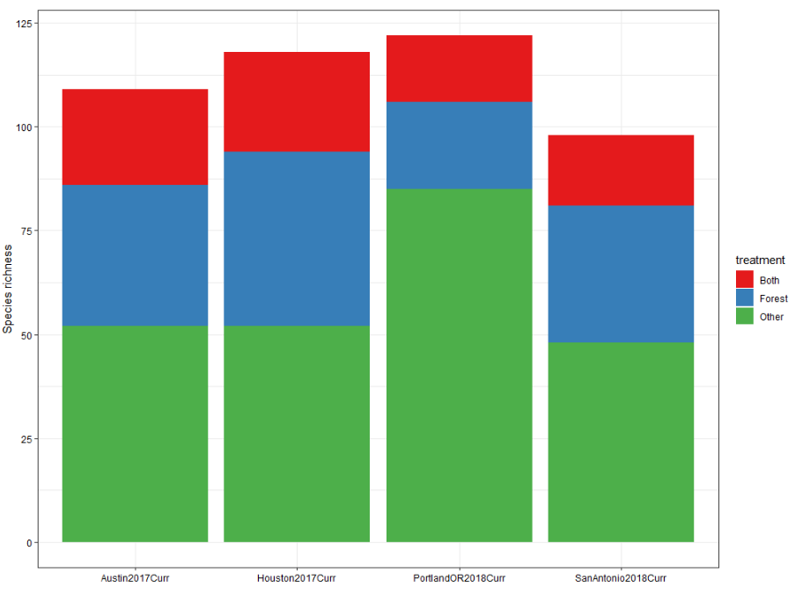

Figure 2. The total overall species sampled in forest, compared with other land use types, for the four cities in our analysis.

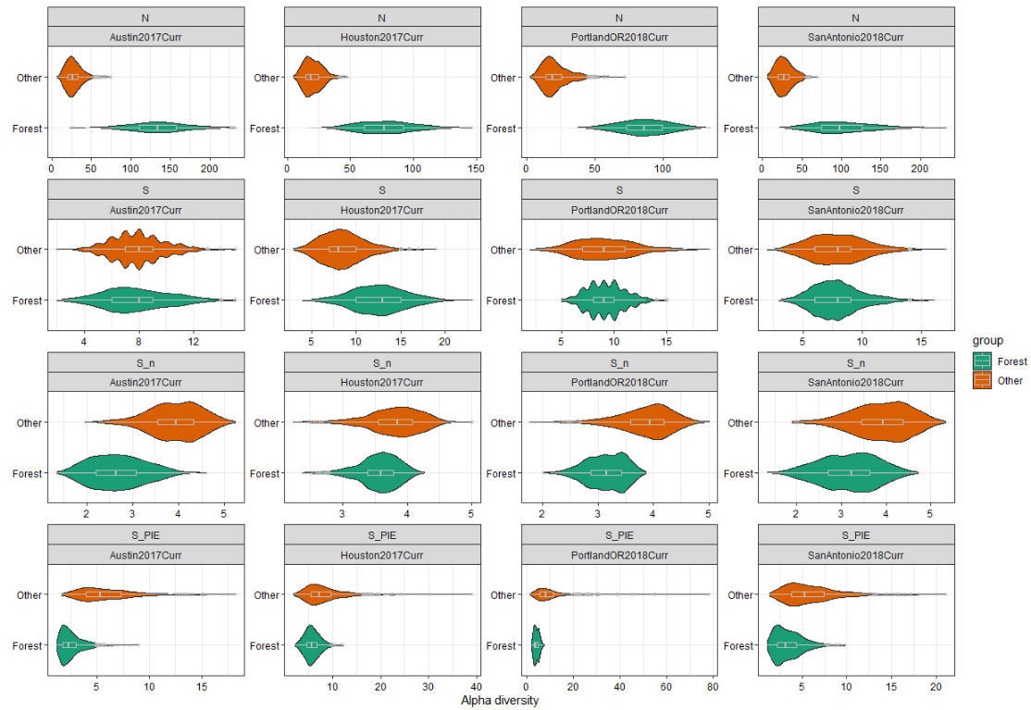

Figure 3. The results of our analysis for alpha diversity, showing the increase in abundance of trees compared with other land use types, the XXXXXXXX.

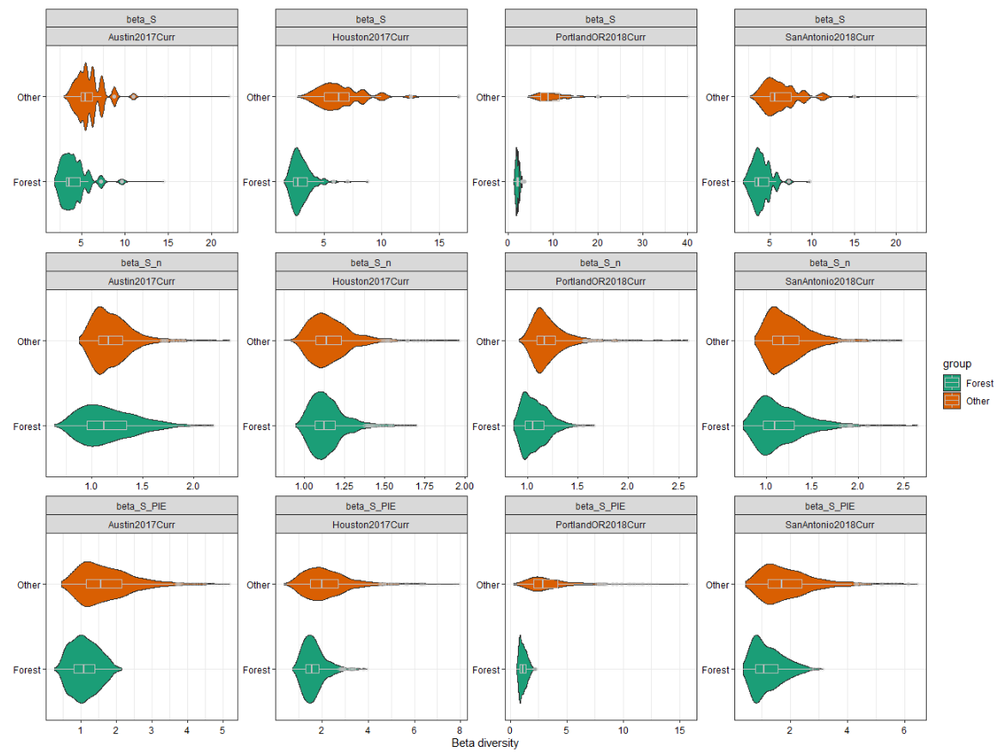

Figure 4. The results of our analysis for beta diversity, for species richness (top row), rarified species richness (middle row), and proability of interspecific encounter rate (bottom row).

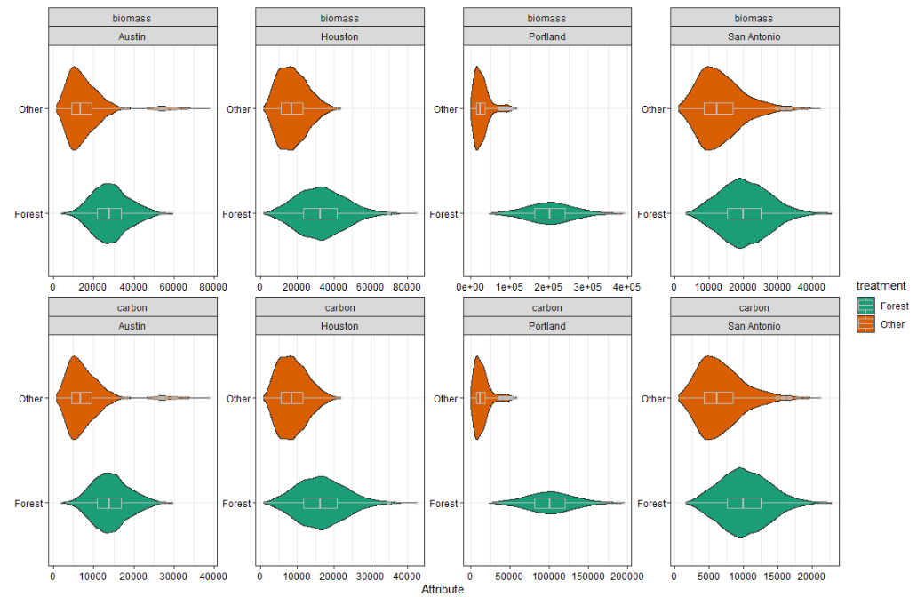

Figure 5. The resampled biomass (top row) and carbon (bottom row) for each city, showing that both biomass and carbon are greater in forests than other land uses.

Tables

Table 1. A summary of the number of sites, and total species richness, included from each of the four cities included in our analysis.

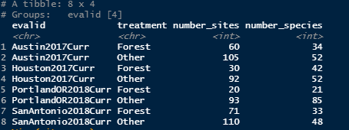

Table 2. Model results for three models, one for each diversity response variable.

